[Sunny Homeland]

Project Plan

Version 2.0

# . Project Plan Version Control

|  |  |  |  |
| --- | --- | --- | --- |
| **Version** | **Date** | **Author** | **Change Description** |
|  |  | Cloud | 2023.2.7 V1.0   * Document created |
|  |  | Johnny | 2023.2.8 V1.1   * Some advice on schedule management and estimation |
|  |  | Cloud | 2023.2.21 V1.9   * Change almost every part according to Oli’s advice * Update breakdown according to staff change * Update risk management and risk management according to real-time progress * Update cost management |
|  |  | Johnny | 2023.2.22 V2.0   * Update Project Scope |

. Contents

. Project Plan Version Control 1

. Executive Summary 3

. Scope Management 4

. Overview – Project Scope 4

. Work Breakdown Structure 4

. Scope Change Procedures 4

. Time Management 5

. Overview – Project Schedule 5

. Team Organization 5

. Cost Management 6

. Overview – Funding Sources & Budget 6

. Project Costs 6

. Quality Management 8

. Overview – Quality Priorities 8

. Quality Management Plan 8

. Risk Management 9

. Overview – Project Risk Tolerance 9

. Project Risks 9

. Assumptions 9

. Communications Management 10

. Overview – Communications Expectations 10

. Communications Plan 10

. Procurement Management 11

. Procurement Plan 11

. Approvals 12

. Prepared by 12

. Approved by 12

# . Executive Summary

The ultimate goal of the project is producing a complete game, who has at least 30 minutes’ process and enough elements and can bring complete emotional experience to players.

Except for a playable game, we also want to deliver complete and neat level design documents, art design documents and function implementation code module.

In different parts we could have different risks. The biggest problem may come from programming, because our game has a few of unique gameplay function, it may take a lot of time to make it true. In the art and design part, a big problem may be inadequate productivity and efficiency. In another word, we may not be able to guarantee both quality and quantity of our game.

According to the timetable, except for the 2 normal rest day in a week we will have no more holiday.

Timeline and milestone contains:

* Project starts (week 1 begins)
* First all function level demo (before week 4 ends)
* A complete playable game with all levels (before week 6 ends),
* Optimization and iteration (before week 7 ends)
* Project ends (week 7 ends)
* *We see a week begins at Saturday and ends at Friday

# . Scope Management

## . Overview – Project Scope

Our game is a 2D, 30-minute puzzle fixed angle platformer made in Unity. Art style is simple cartoon. There are 2 player characters and 5 NPCs (1 friendly and 4 enemies) all of which will need full art treatment. There will be 9 animations, 1 of which will be shared amongst all characters. The game consists of 15 levels, which contains 3 parts of scene art: 6 backgrounds, 2 playable items, and 16 interactable items which have unique dialogues. The game will feature 3 illustrated cinematics and 4 unique lines of dialogue will be needed. There will be 8 music tracks and 9 sound effects. The game will be developed by a team of 5 in a 1-month time frame.

Our project mainly has 3 parts of work: art, design and programming. Art part is responsible for all the static and dynamic art, the former includes scenes and objects and the latter mainly includes figure art. Design part decides all the game elements, all level gameplay, emotional communication, UI, etc. Programming parts need to achieve all the function in game and build all levels according to the level design document.

## . Work Breakdown Structure

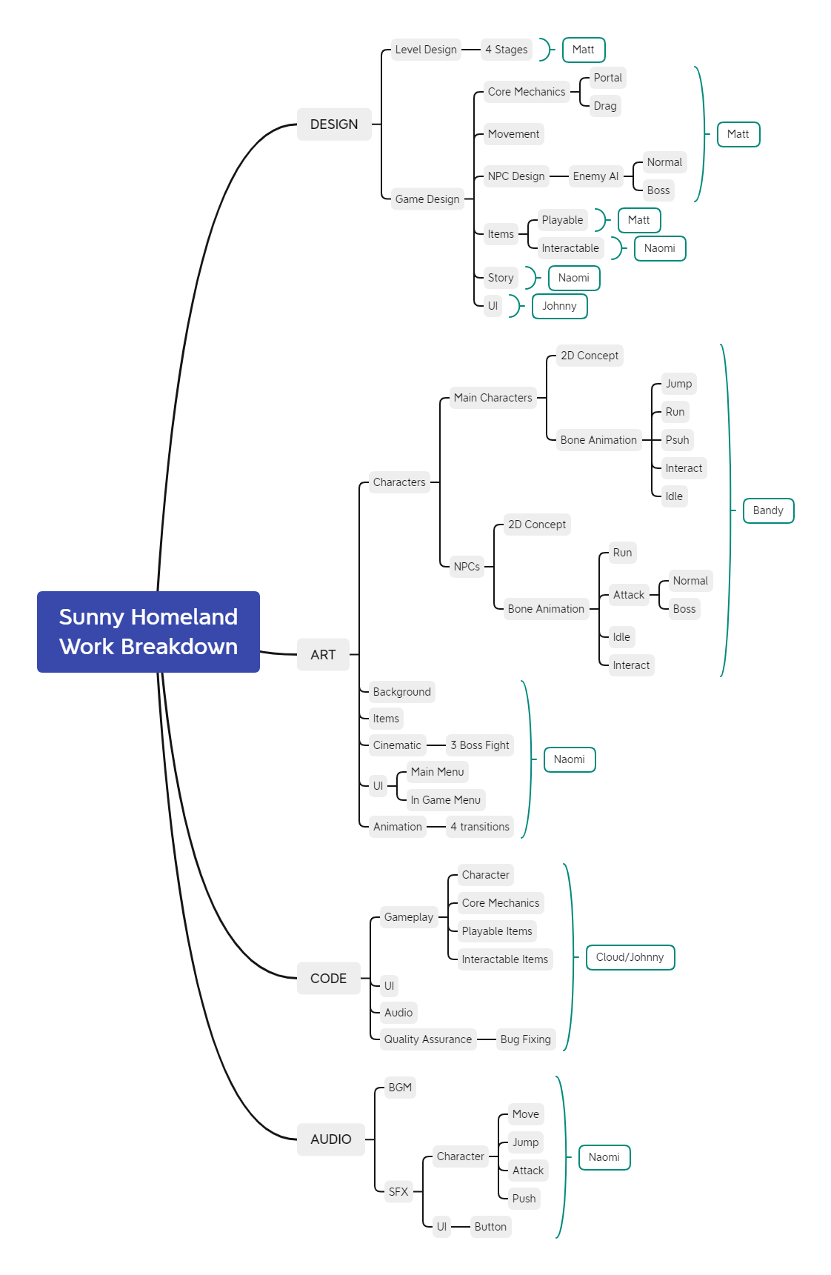

## . Scope Change Procedures

When Artist and Design meet problems they should first propose potential changes to Lead Art and Lead Design, if things can’t be determined then call the whole team to decide. The same as Lead Art reports to Lead Design and Lead Design reports to PM.

# . Time Management

## . Overview – Project Schedule

|  |  |  |  |
| --- | --- | --- | --- |
| **Milestone** | **Date** | **Deliverable** | **Approval** |
| M0-  Project Starts | Week 1 begins | / | / |
| M1  Metaphase | Week 4 ends | An all function level demo | PM |
| M2  Late Stage | Week5 ends | A complete playable game | PM |
| M3  Polish | Week 6 ends | Iteration | PM |
| M4  Project Ends | Week 7 ends | Final game | Producer (Oli) |

## . Team Organization

|  |  |  |
| --- | --- | --- |
| **Project Team Member(s)** | **Project Team Role** | **Responsibilities** |
| Bandy | Art | Draw dynamic and scene art. |
| Naomi | Lead Art and Scriptwriter | Write scripts, draw static art and arrange sound assets. |
| Matt | Design | Design all levels. |
| Johnny | Lead Design and Programming | Check all design and art details. Achieve functions and build levels. |
| Cloud | Programming and PM | Manage the team and project progress. Achieve functions and build levels. |

# . Cost Management

## . Overview – Funding Sources & Budget

No money resources, tiny pecuniary expenditure is by members themselves. All hardware and software are being provided by SHVFS.

## . Project Costs

|  |  |  |  |
| --- | --- | --- | --- |
| **Human Resources** | | | |
| **Role Type** | ***Quantity*** | ***Unit Cost*** | ***Subtotal*** |
| 2 Art | *1* | *0* | *0* |
| 1 Design | *1* | *0* | *0* |
| 2 Programming | *1* | *0* | *0* |
| **Total Human Resource Costs** | | | **￥0** |

|  |  |  |  |
| --- | --- | --- | --- |
| **Consumable Resources** | | | |
| **Role Type** | ***Quantity*** | ***Unit Cost*** | ***Subtotal*** |
| / | / | / | / |
| **Total Consumable Costs** | | | **￥0** |

|  |  |  |  |
| --- | --- | --- | --- |
| **Non-Consumable Resources** | | | |
| **Type** | ***Quantity*** | ***Unit Cost*** | ***Subtotal*** |
| Computers | 5 | 0 | 0 |
| Interactable items Arts | 15 | 22 | 330 |
| Background Arts |  |  |  |
| **Total Non-Consumable Costs** | | | **￥530** |

|  |  |
| --- | --- |
| **Totals** | |
| **Resource Type** | ***Subtotal*** |
| Human Resources | 0 |
| Consumable Resources | 0 |
| Non-Consumable Resources | 530 |
| **Total Budget** | **￥530** |

# . Quality Management

## . Overview – Quality Priorities

All functions being achieved is the major priority in terms of quality, then the quality of single level’s design. In contrast, the length of the game and art quality are not so important.

## . Quality Management Plan

|  |  |  |
| --- | --- | --- |
| **Quality Standard** | **Quality Assurance** | **Quality Control** |
| Function Achieved | Work hard and ask the teacher with an open mind. | Check twice a week   * Is it stable? Is there a bug? * If it is simple? Is it easy for other team members to achieve? |
| Level Design Quality | Play it myself and give optimization advice. | Check twice a week   * Is it fun? * Is it intuitive? * Is it easy for programming to achieve? |
| Art Quality | Contact with other groups’ Art, figure out more efficient way to help our Art achieve their work. Provide financial support for outsourcing when necessary. | Check twice a week   * Is the art style unified? * Is th art style fit our game’s type? |
| Game Length | Art and Design work hard. | Check twice a week   * How long is the whole game? * How is the user flow? |
|  |  |  |

# . Risk Management

## . Overview – Project Risk Tolerance

Art part is less important than gameplay in our game, also considering we have 2 full-time art, art part could afford more risk than others.

Overall, we can afford that our game didn’t meet expectations in a few parts like CG, story telling, emotional communication, etc. But our game almost can’t afford any risk in gameplay function achieved, no matter the team or clients.

## . Project Risks

|  |  |  |  |  |  |
| --- | --- | --- | --- | --- | --- |
| **Risk** | **Impact** | **Probability** | **Mitigation Plan** | **Contingency Plan** | **Status** |
| If the scheduled work was not completed on time then the whole project progress will be delayed. | Med | High | Everybody works harder. People who are free should offer help. Allow time when making plans. | Everybody work over time. | M2-  M3- |
| If function can not be realized, then the whole gameplay and level design will be pushed down and started over. | High | Low | Cloud and Johnny will work overtime to make this not happen. Ask for foreign assistance. | Write longer scripts and make our game a normal story-telling game. Or custom code for each level. | Mx→M0 |
| If the art and level design qualities don’t meet expectations then the overall quality of our game will decline. | Low | Med | Make careful phased assessment. | If there’s still time, polish and iterate it; if there is not, then we just ignore them. | None |

# . Communications Management

## . Overview – Communications Expectations

The most frequent communication is communication within team, which consists of two kinds: discussion and check. Discussion most happen in single department and if there is plenty of time, the object of the discussion is mainly for the quality; if not, the object is to finish the thing as soon as possible. Check happen when a part of work is done, and can happen both in single department and between departments. The person in charge should decide whether accept that or give more time to polish and iterate the work. If he can’t decide himself he can turn to his superior.

Except for our team and producer, there is no other stakeholders. So the only external communication is between our team and producer Oli (also as supporter). At least we have 1 day a week can we achieve a face to face communication with very high efficiency, both as phased check and assistance. If we meet some very intense problems that can’t be finished by our team we will also turn to Oli for help at irregular time.

## . Communications Plan

|  |  |  |  |
| --- | --- | --- | --- |
| **Stakeholder(s)** | **Information Needed** | **When/How Often** | **Means Of Delivering The Information** |
| Oli | Weekly Progress | weekly | Do a presentation by one person different for each week |
| Oli | Problems met | Meeting intensely difficult problems | The person who meets problems should try to contact with Oli in any way. |
| Superior | Work | Work done | Superior should check the work and give his judgement and advice. |
| Superior | Things need to be determined | Indecisiveness | Superior should explain more about the mission and make sure subordinates get what he means. |
| Colleague (Same Department) | Things need to be determined | Indecisiveness | Figure out the way together. |

# . Procurement Management

## . Procurement Plan

|  |  |  |  |
| --- | --- | --- | --- |
| **Resource Req.** | **Source** | **When Required** | **Team Member Responsible** |
| Arts of interactable items | Naomi’s friend | Week 5 ends | Naomi |
| Background Arts | Naomi’s friend | Week 6 ends | Naomi |
|  |  |  |  |

# . Approvals

## . Prepared by

__________________________________

Project Manager

## . Approved by

__________________________________

Senior Producer